**Final Deliverables**

**Team ID**: PNT2022TMID15947

**Project Name**: Industry – specific intelligent fire management system

**Team Members:**

1) Balaji P (Team Leader)

2) Akilan A

3) Dinesh S

4) Arun R

Preview

WOKWI SIMULATOR :

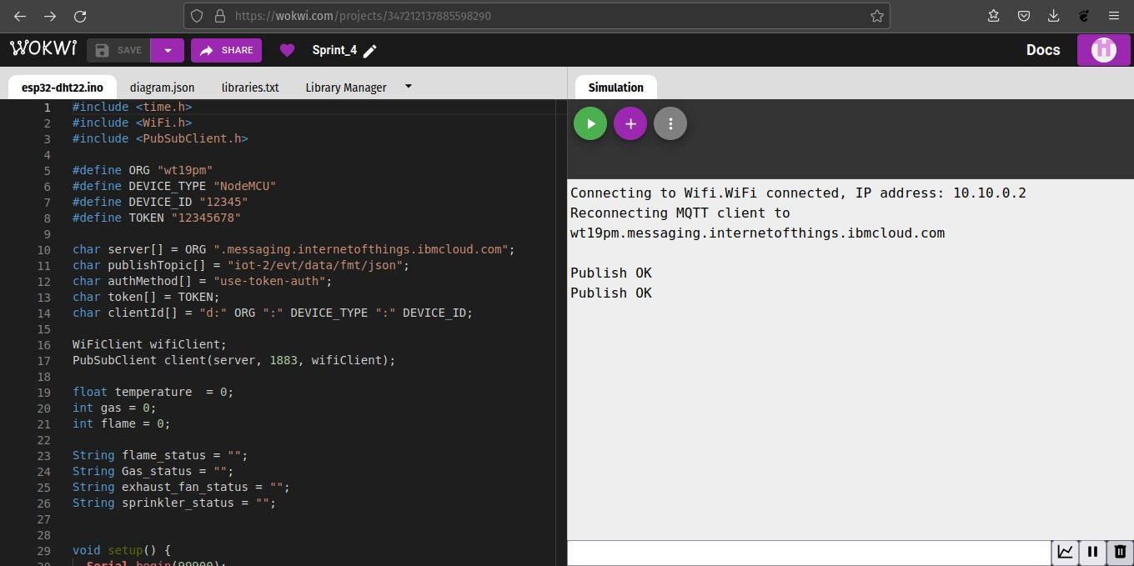

# Node Red:

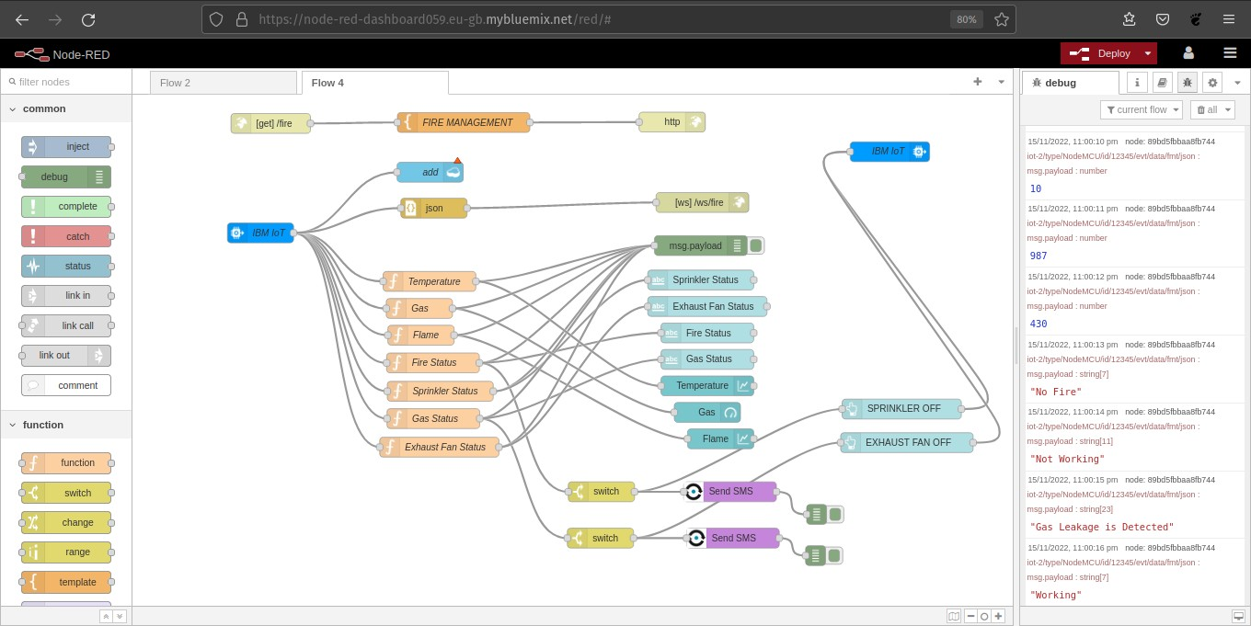

IBM WATSON IoT:

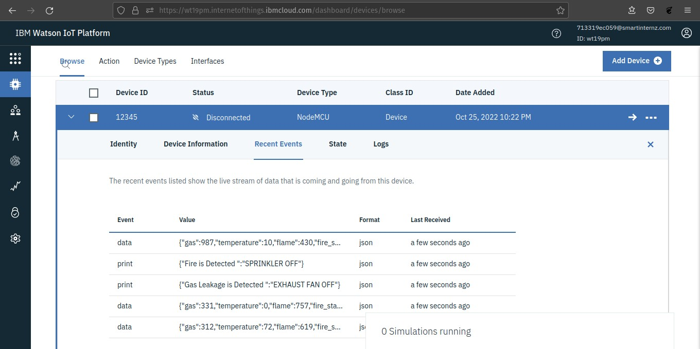

# NODE RED (UI):

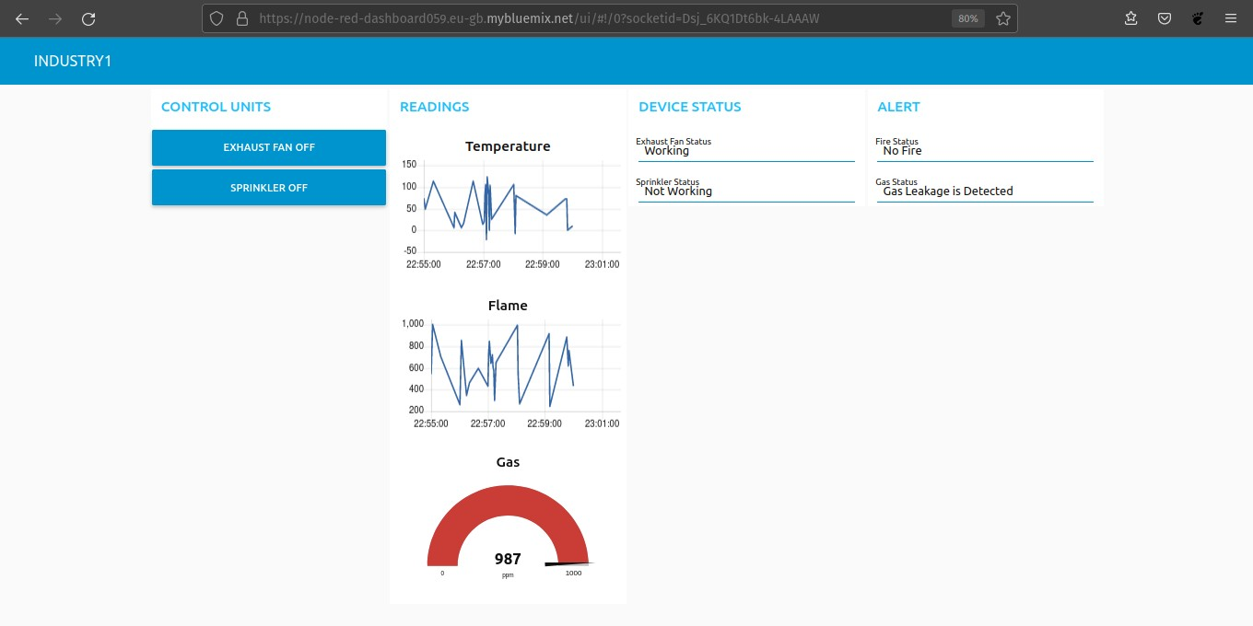

WEB PAGE SOCKET:

